PowerMark Fly Laser Reference

1 Summary 1
1.1 Software Introduction 1
1.2 Software function 1
1.3 Gui description 1
2 File 2
2.1 New 2
2.2 Open 2
2.3 Save as 3
2.4 Save 3
3 Edit 4
3.1 Copy 4
3.2 Multi copy 4
3.3 Redo 5
3.4 Group/Split Group 5
3.5 Merge/Split 6
3.6 Array 6
3.7 Fill 6
3.8 Align 7
3.9 Distribute/Reorder 7
3.10 Select all 8
4 Transform 9
5 Setting 10
5.1 Laser calibrate 10
5.2 Laser parameter 16
5.2.1 Fiber 16
5.2.2 CO2 18
5.2.3 YAG 20
5.3 IO Config 23
5.4 Alarm config 26
5.5 System 27
5.6 Serialport 28
5.6.1 Default protocol 28
5.6.2 Character stream protocol 28
5.6.3 Debug mode 28
5.7 Network 29
5.8 Authority 29
5.9 Param manager 29
5.10 History record setting 29
5.11 Touch calibration 29
5.12 About 30
6 Entity list 31
7 Res manager 32
8 Toolbar 33
8.1 Time 33
8.2 Date 34
8.3 Text 34
8.4 Serial number 35
8.5 Barcode 35
8.6 Line 36
8.7 Rectangle 37
8.8 Ellipse 37
8.9 Vector 37
8.10 Composite text 38
8.10.1 Static Text 38
8.10.2 Time 38
8.10.3 Date 38
8.10.4 Scanner 39
8.10.5 Serial number 39
8.10.6 Database 40
8.10.7 New line 40
8.10.8 Bridge text 40
8.10.9 Random code 41
8.11 Image 41
8.12 Delayer 41
8.13 Database 41
8.14 VIN 41
8.15 Delete 42
8.16 Undo 42
8.17 Login 42
8.18 Zoom in/out 42
8.19 No zoom 42
8.20 Watch 42
9 Control panel 43
10 Mark parameters 44
10.1 PenNum 44
10.2 Mark parameters manager 48
11 Print mode 49
11.1 Static 49
11.2 Fly 50
11.3 Linepipe 51
12 Mark bar 52
13 Status bar 54

1 Summary

1.1 Software Introduction

1.2 Software function

1.3 Gui description
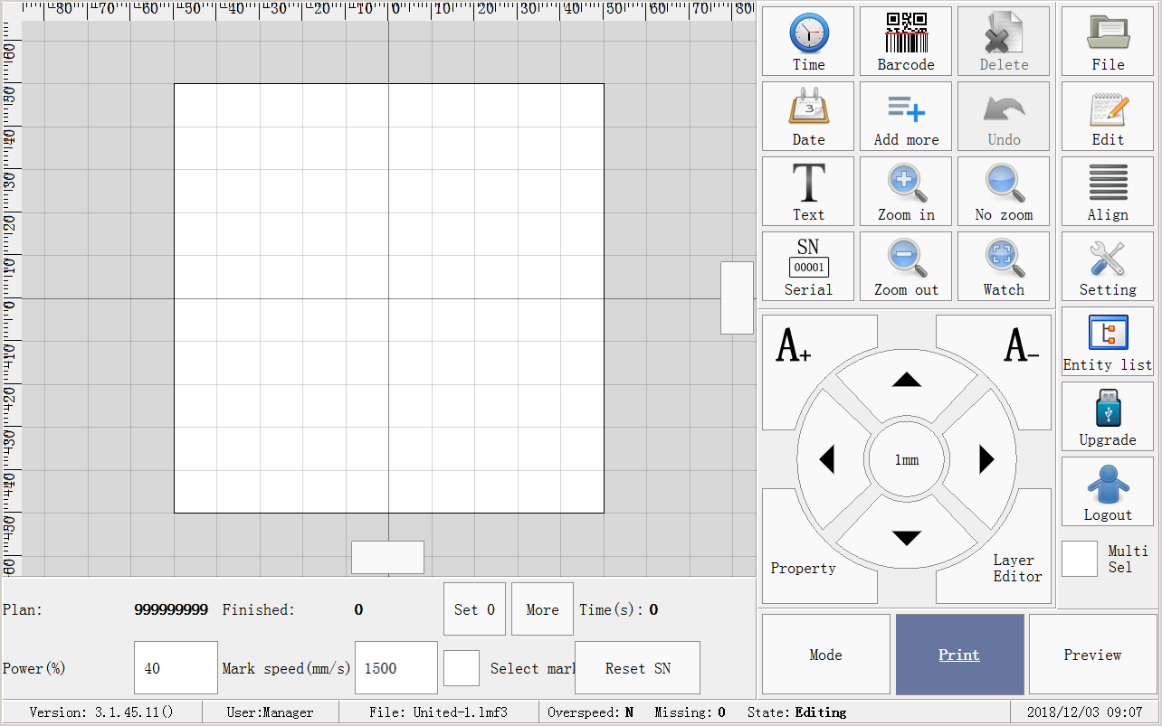
Image 1-1 Layout1(example as follow description)
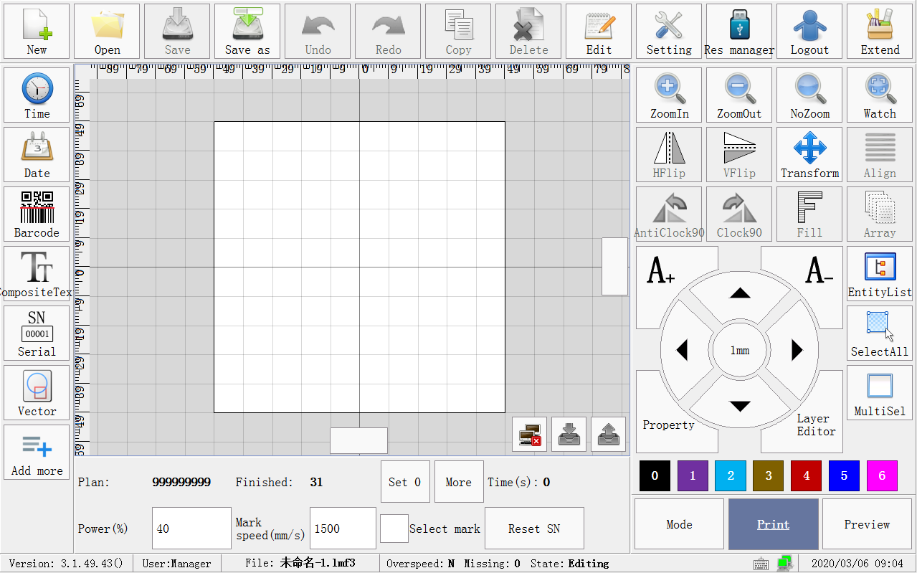
Image 1-2 Layout2

2 File
Implements regular document operations,including new,open,save as and save.

2.1 New
Create empty new document.
Click new menu,input the document name in editor,see image 2-1.
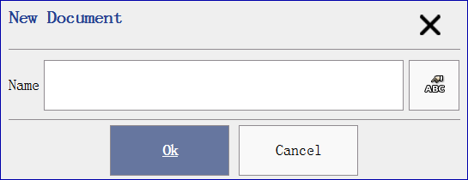
Image 2-1

2.2 Open
Open laser document.Laser document’s file suffix is “lmf3”.See image 2-2.
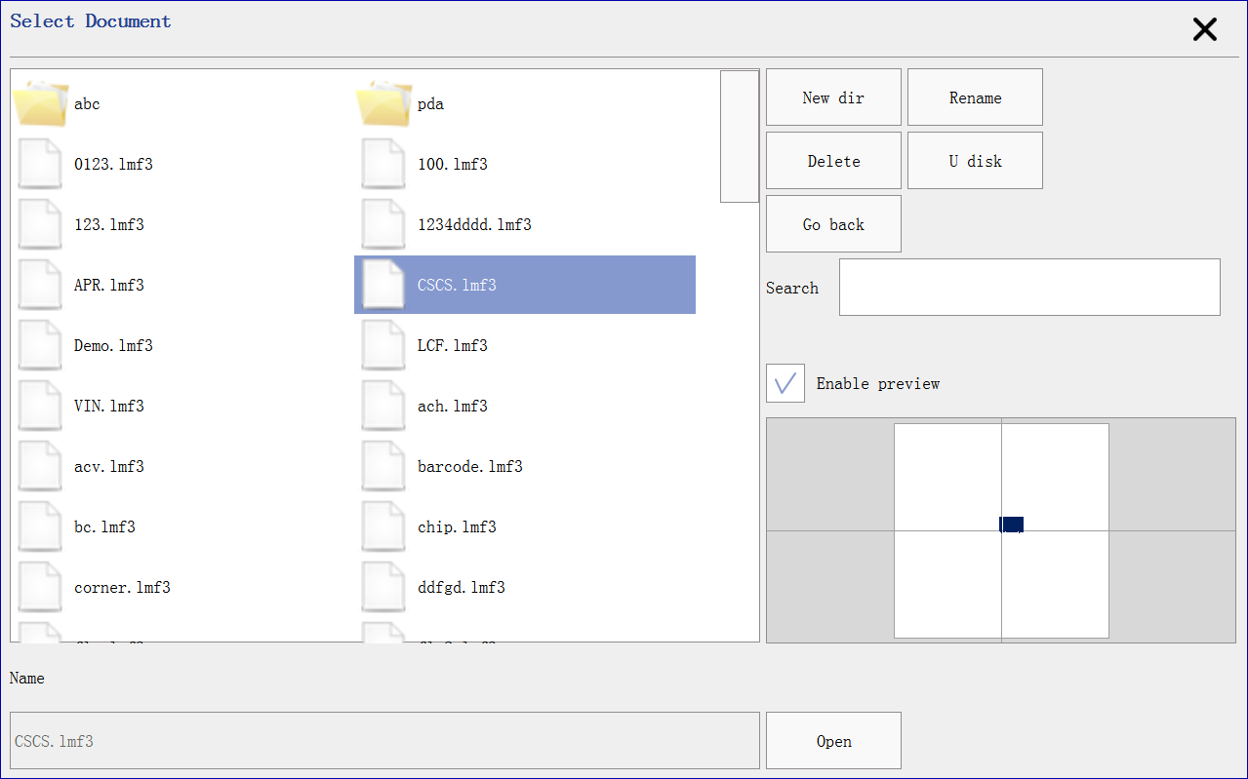
Image 2-2
Preview document content while selecting if enable preview is checked.
Input keyword in search editor to quick locate document.
Click U Disk (only support FAT32 format) can browser the documents if it has plugin in the laser board.

2.3 Save as
Save as document with different name.

2.4 Save
Save current edito document to storage.

3 Edit

3.1 Copy
Clone current selected objects.

3.2 Multi copy
Clone selected objects to multi objects.
Multi copy is similar with copy,multi copy finish clone operation more times,and arrange them in row and column.
Column count:clone count in horizontal direction.
Row count:clone count in vertical direction.
Direction:decide the clone object direction while arranging.
Horizontal direction means arrange them from left to right and up to down after clone finish.See image 3-1.
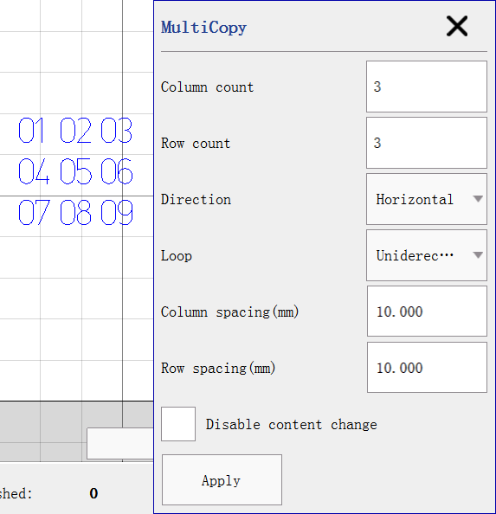
Image 3-1
Vertical direction means arrange them from up to down and left to right after clone finish.See image 3-2.
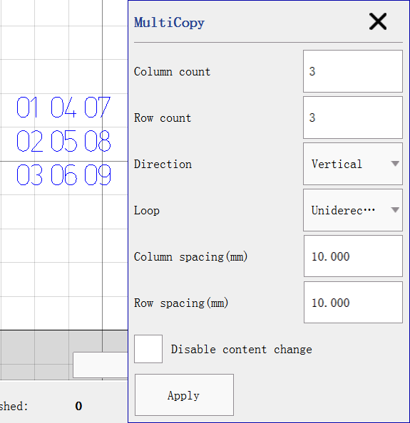
Image 3-2
Loop
Unidirection:always clone begin L->R(if horizontal direction) or T->B(if vertical direction).
Bidirection:clone begin L->R,R->L(horizontal direction) cycle or T->B,B->L(vertical direction) cycle.
Column spacing:column offset after clone finish.
Row spacing:row offset after clone finish.
Disable content change:ignore data change while cloning if un-checked,or clone next data(such serialnumber) if checked.

3.3 Redo
Redo previous cancel operations.

3.4 Group/Split Group
Keep selected objects’ property unchanged after group as one object.Grouped object can be move,scale,select,copy and other action.
Split group can split the grouped object to multi objects with property unchanged.For example,a rectangle and a circle can be group as one object,split the object can recovery the rectangle and circle object.

3.5 Merge/Split
Merge the selected objects to a complex polygon object.Merged object can be merge with other objects again.
Split the object to multi polygon objects.
If object begin to be split contains more than 100 polylines,it will split with 100 polyline as a block.For example,the object contains 320 polylines,it will split to 4 objects,each object contains 100,100,100,30 polylines.Split the block again if you want to modify the object,because it can be split completely if contains less than 100 polylines.

3.6 Array
Similar with [3.2 Mult copy],but array do not create new objects,while multi copy will create new objects.

3.7 Fill
Fill closed-polygon with lines.
Mark outline:whether enable outline mark.
Fill type:
Unidirection:always scan fill from left to right.
Bidirection:scan fill as bidirection(from left to right then right to left).
Bow:fill connected lines if two nearby line in the same fill block.
RingShape:scan fill as rings.
Spacing:line spacing.
Margin:fill line margin.
Angle:fill line rotation angle.
Custom mark params:enable to change mark effect.
Power:laser mark power.
Speed:laser mark speed.
Frequency:laser mark frequency.
Click show multi fill can setting multi fill.Mark sequence is Fill1,Fill2,Fill3.

3.8 Align
Implements align operation between selected objects.
Align left:align selected objects’ left to the left of selected region.
Align horizontal center:align selected objects’ horizontal center to the center of selected region.
Align right:align selected objects’ right to the right of the selected region.
Align top:align selected objects’ top to the top of selected region.
Align vertical center:align selected objects’ vertical center to the center of selected regions.
Align bottom:align selected objects’ bottom to the bottom of the selected region.

3.9 Distribute/Reorder
Distribute:rearrange selected objects layout.
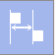:Refer object left position to arrange horizontal layout with equal distance.
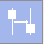:Refer object horizontal center position to arrange horizontal layout with equal distance.
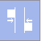:arrange object horizontal layout with equal distance.
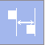:Refer object right position to arrange horizontal layout with equal distance.
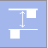:Refer object top position to arrange vertical layout with equal distance.
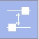:Refer object vertical center position to arrange vertical layout with equal distance.
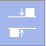:Refer object vertical layout with equal distance.
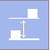:Refer object bottom position to arrange vertical layout with equal distance.
Reorder:contains 4 rules to rearrange selected objects.
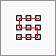:horizontal bow order.
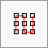:vertical bow order.
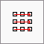:horizontal uniderection order.
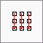:vertical uniderection order.

3.10 Select all
Select all objects in current edit document.

4 Transform
Quick options contain horizontal/vertical mirror,anti-clockwise/clockwise 90 degree rotation.
The advance transform implements scale,rotate,invert and tilt.
Scale:scale selected objects’ size.
Rotate:rotate selected objects’ with angle value.
Invert:invert selected objects in horizontal or vertical line.
Tilt:tilt selected objects with clock or anti-clock wise angle.

5 Setting
Implements global setting of laser marking board.

5.1 Laser calibrate
laser marking machine consists two lens. some physical properties of the lens and the light path causes morphing of the actual marked graphs. Some parameters are adjusted appropriately to make the actual marked graphs close to the designed graphs in software.See Image 5-1.
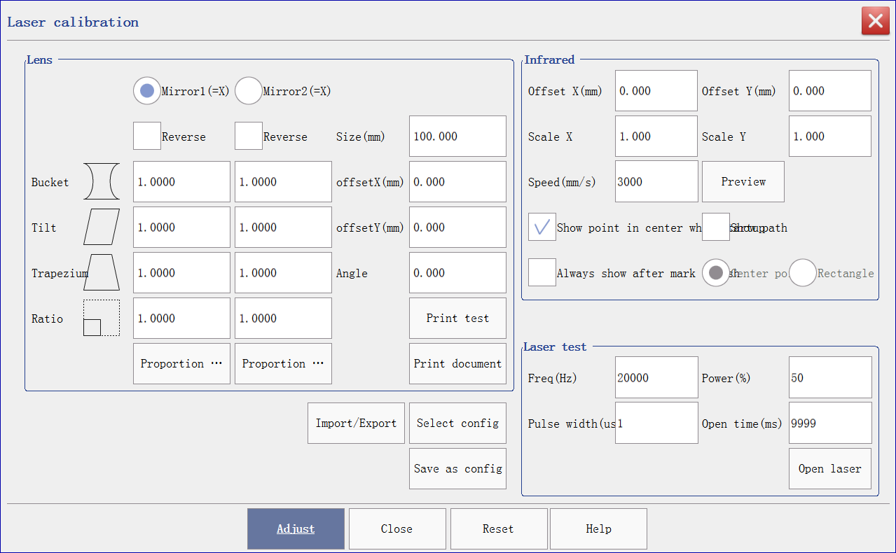
Image 5-1
Lens:
Lens1(=X):the output signal 1 from control card is as x-axis of user’s coordinate system.
Lens2(=X):the output signal 2 from control card is as x-axis of user’s coordinate system.
Reverse: reverse to the output of lens.
Bucket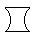:calibrate the parameter accurately when bucket distortion appears.
Tilt:calibrate the parameter accurately when tilt distortion appears.
Trapezium:calibrate the parameter accurately when trapezium distortion appears.
Ratio:adjust the scaling ratio for calibration when the expect size ( the graphics size set in the software) is not the same as the actual size(the size of the actual marked graphics sample). Ratio value = expect size / actual size.
Note: follow parameter must be set after the calibration.
Size:the size of working area.It is normally set as the actual maximum marking range of lens.
OffsetX:horizontal offset of marking range.
OffsetY:vertical offset of marking range.
Angle: the whole mark rotates anticlockwise at an angle.

Normal calibrate steps are:
1.Lens coordinate system calibrate;
2.Lens reverse calibrate;
3.Bucket calibrate;
4.Tilt calibrate;
5.Trapezium calibrate;
6.Ratio calibrate;
7.Offset calibrate;

Step1.Lens coordinate system calibrate
①Press button to keep in initial state;
②Adjust lens focal distance;
③Setting lens region size,100mm in default;
④Press button to mark rectangle;
⑤See and check the arrow direction of x and y axis,if found one of the below effect,checked [Lens2(=X)];
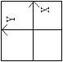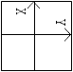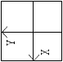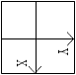
⑥lens coordinate system calibrate finished;
Step2.Lens reverse calibrate;
①[Reverse] are unchecked in default;
②Press button to mark rectangle;
③See and check mark effect:
- 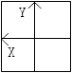,checked reverse in x axis;
- 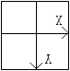,checked reverse in y axis;
- 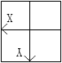,checked reverse in x and y axis;
- 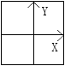,means reverse calibrate finished;

Step3.Bucket calibrate;
①Default bucket value is 1.0;
②Press button to mark rectangle;
③See and check effect:
- 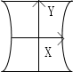,decrease bucket value in x axis;or 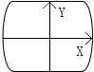,increase bucket value in x axis;
- 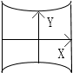,decrease bucket value in y axis;or 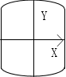,increase bucket value in y axis;
Step4.Tilt calibrate;
①Default tilt value is 1.0;
②Press button to mark rectangle;
③See and check effect:
- 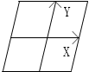,decrease tilt value in x axis;or 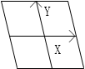,increase tilt value in x axis;
- 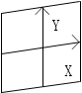,decrease tilt value in y axis;or 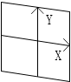,increase tilt value in y axis;
Step5.Trapezium calibrate;
①Default trapezium value is 1.0;
②Press button to mark rectangle;
③See and check effect:
- 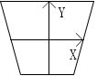,decrease trapezium value in x axis;or 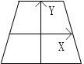,increase trapezium value in x axis;
- 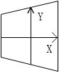,decrease trapezium value in y axis;or 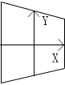,increase trapezium value in y axis;
Step6.Ratio calibrate;
①Default ratio value is 1.0;
②Press button to mark rectangle;
③Measure the actual mark width,if not equal with target width,please click ,input the target width and actual measured width,click OK,and repeat step②;
④Calibrate height is same with step③;
Step7.Offset calibrate;
①Default offset value is 0.0;
②Press button to mark rectangle;
③If mark object is in the right as expected,decrease x offset value;If in the left as expected,increase x offset value;
④If mark object is in the top as expected,decrease y offset value;If in the bottom as expected,increase y offset value;

DB25 lens wiring instructions
Lens controls by digit signal and can be connect to digit lens directly.See Image 5-2.
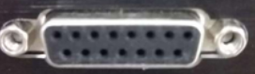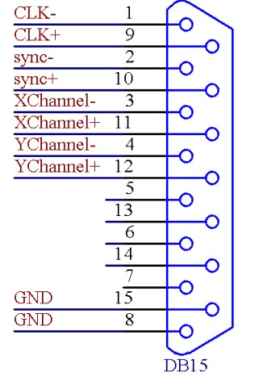
Image 5-2
Pin | Signal name | Instruction
1, 9 | CLK—/CLK+ | Clock signal—/Clock signal+
2,10 | SYNC—/SYNC+ | Sync signal—/Sync signal+
3,11 | XChannel—/ XChannel+ | Lens X signal—/Lens X signal+
4,12 | YChannel—/ YChannel+ | Lens Y signal—/Lens Y signal+
5,13 | NULL | Reserved
6,14 | NULL | Reserved
7 | NULL | Reserved
8,15 | GND | Ground
Infrared calibrate
Infrared can be used in preview and position.It should be calibrate while dis-coincide with laser.
Speed:Infrared speed while previewing.
Offset X:horizontal offset for calibrate to actual mark position.
Offset Y:vertical offset for calibrate to actual mark position.
Scale X:horizontal scale for calibrate to actual object size.
Scale Y:vertical scale for calibrate to actual object size.
Show point in center while startup:if check this option,it will show infrared point in lens center after machine startup finished.
Show path:show region of marking objects if uncheck this option,or show total path if checked.Warning:Image object will be preview as a rectangle.
Always show after mark:if check this option,it will always infrared preview with new printable document objects’ path or rectangle.
Preview:click preview to show.Press left/right/up/down key to adjust infrared effect and calibrate parameters will be updated after finish preview.
Laser test
Laser will be always opening to test whether power is sufficient.

5.2 Laser parameter

5.2.1 Fiber
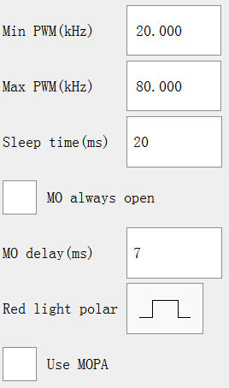
Image 5-3
Min PWM:the minimum allowable frequency of PWM signal from the laser.
Max PWM:the maximum allowable frequency of PWM signal from the laser.
MO delay:open the main oscillator before the fiber laser sends out the light. The light can be sent out while opening 7ms main oscillator by default. For the specified latency, please check the specified type in laser instructional manual
Sleep time:oscillator should be turned off to save energy of fiber laser when marking is finished. Turn off the oscillator in 20ms when laser finishes marking by default. Increase sleep time to make the interval time of twice markings shorter than sleep time and reduce continuous turn on and up of the oscillator.
Red light polar:polar switch for red light.
Use MOPA:mopa supported.
Power mapping:setting the ratio between user define and actual.

Fiber DB25 pin instruction
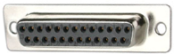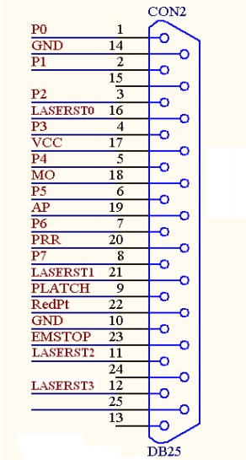
Image 5-4
Pin | Signal name | Instruction
1-8 | P0-P7 | Laser power.TTL output.
9 | PLATCH | Power latch signal.TTL output.
10,14 | GND | Ground
11,12,16,21 | LASERST0-3 | Laser state input
17 | VCC | 5V power output
18 | MO | Main oscillator switch signal.TTL output.
19 | AP | Power amplifier switch signal.TTL output.
20 | PRR | Repeat pulse frequency signal.TTL output.
22 | RedPt | Reserved
23 | EMSTOP | Quick stop switch signal.TTL output.
13,15,24,25 |  | Hang,no connection.

5.2.2 CO2
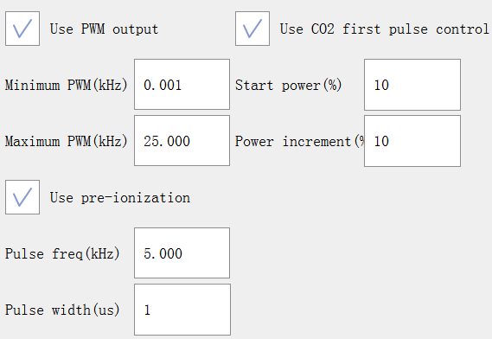
Image 5-5
Enable PWM output:CO2 laser can control power by PWM.The power of CO2 laser can not be adjust if this function is disabled.Marking is always used the maximum power and other parameter is not available.
Min PWM: the minimum allowed frequency of laser PWM signal.
Max PWM: the maximum allowed frequency of laser PWM signal.
Enable pre ionization :part of CO2 laser need this signal to work.
Pulse frequency:the pulse frequency of pre ionization .
Pulse width: the pulse width of pre ionization.
Enable CO2 first pulse control:To solve the problem of CO2 printer t “deep starting dot ” caused at the beginning of marking because of too much energy savings of Laser when its power is too strong or the interval time is too long.
Start power:the percentage of marking power set for fist pulse after light is sent out.
Power increment:the percentage of the next pulse added from the first pulse. It keeps adding to reach marking power set.

For example:print “text”, set marking power 80%, begin power 10%,add power 20%. After opening the light, the first pulse power is 8%, the second pulse power is 24%, the third pulse power is 40%, the forth pulse power is 56%, the fifth pulse power is 72%, the sixth pulse power is 80%. It keeps 80% until close light.See image below,pulse width increase to specific power.
CO2 DB25 pin instruction
Image 5-6
Pin | Signal name | Instruction
4 | P3 (CO2_LASER_EN+) | co2 enable signal+.TTL output.
5 | P4(CO2_LASER_EN-) | co2 enable signal-.TTL output.
19 | AP(CO2_PWM+) | co2 pwm+.TTL output.
20 | PRR(CO2_PWM-) | co2 pwm-.TTL output.
10,14 | GND | Ground
17 | VCC | 5V power output
C02 oscillogram
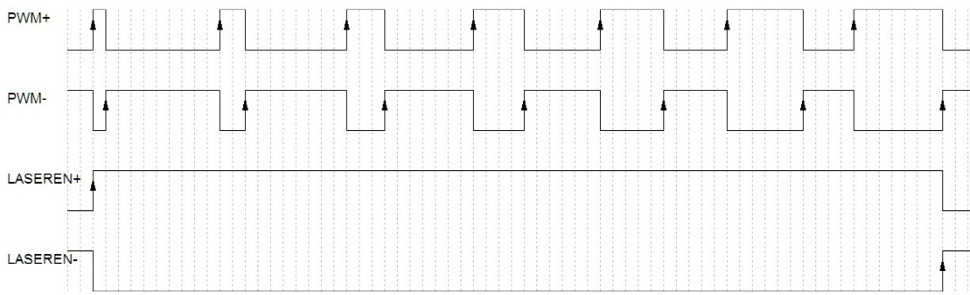
Description:
1.Pin 19 is PWM+ signal of CO2,refer to PWM+ in oscillogram;
2.Pin 20 is PWM- signal of C02,refer to PWM- in oscillogram;
3.Pin 4 is enable signal + of CO2,refer to LASEREN+ in oscillogram;
4.Pin 5 is enable signal - of CO2,refer to LASEREN- in oscillogram;
Parameters of Laser power mapping table
Set the frequency ratio defined by users and the actual frequency ratio to achieve that the actual printing effect is corresponding to the actual power.

5.2.3 YAG
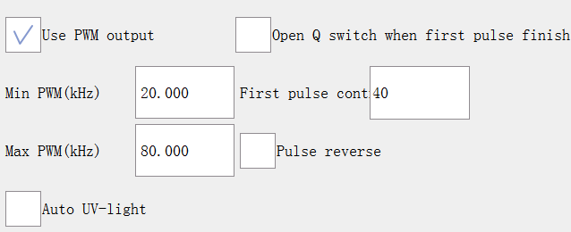
Image 5-7
Enable PWM output:YAG laser can control power by PWM.The power of YAG laser can not be adjust if this function is disabled.Marking is always used the maximum power and other parameter is not available.
Min PWM: the minimum allowed frequency of laser PWM signal.
Max PWM: the maximum allowed frequency of laser PWM signal.
First pulse control:First pulse constrain keep time to avoid first point too deep.
Open Q switch when first pulse finish:Q switch will be open after first pulse constrain finished if checked,or it will be open while first pulse constrain beginning.
Pulse reverse:reverse PWM pulse signal(low to high,or high to low level).
Auto UV-light:auto serialport control start huaray or inno laser machine after startup.
Image below show the First pulse control signal and PWM signal occur in the same time.
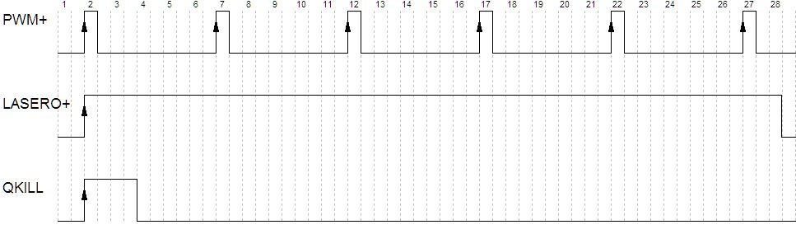
Image below show the PWM signal output after First pulse control signal finished.
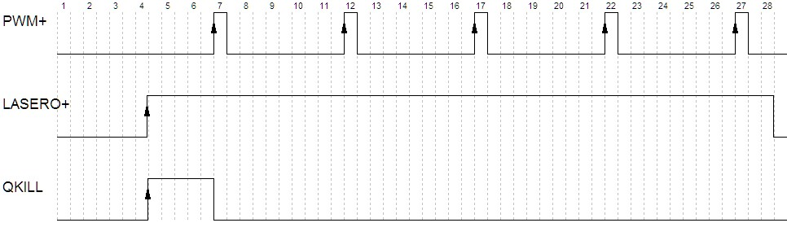
Image below show the PWM signal before Pulse reverse.
Image below show the PWM signal after Pulse reverse.
YAG DB24 pin description
Pin | Signal name | Instruction
6 | P5 (YAG_LASERO+) | YAG laser switch signal+(optical shutter).  TTL output
7 | P6(YAG_LASERO-) | YAG laser switch signal-(optical shutter).  TTL output
8 | P7(YAG_QKILL) | YAG laser first pulse signal constrain.  TTL output
19 | AP(YAG_PWM+) | YAG laser pwm+ output.TTL output
20 | PRR(YAG_PWM-) | YAG laser pwm- output.TTL output
10,14 | GND | Ground
17 | VCC | 5V power output
YAG oscillogram
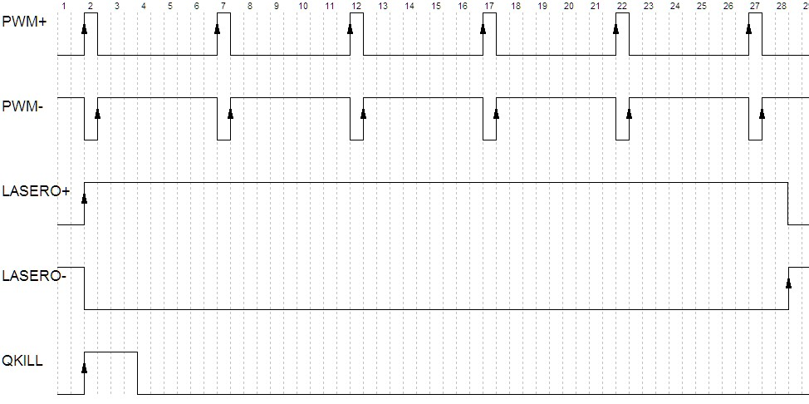
Description
1.Pin 19 is PWM+ signal in YAG,refer to PWM+ in oscillogram;
2.Pin 20 is PWM- signal in YAG,refer to PWM- in oscillogram;
3.Pin 6 is optical shutter signal + in YAG,refer to LASERO+ in oscillogram;
4.Pin 7 is optical shutter signal - in YAG,refer to LASERO- in oscillogram;
5.Pin 8 is first pulse control signal in YAG,refer to QKILL in oscillogram;

5.3 IO Config
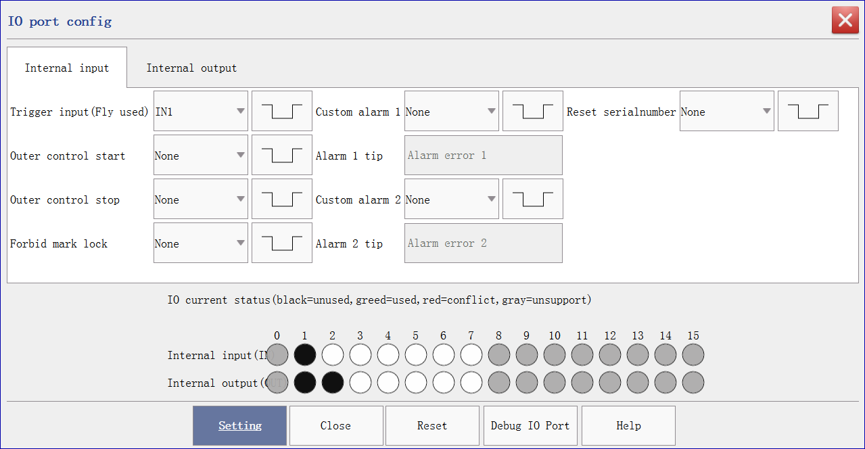
Image 5-8-1 input
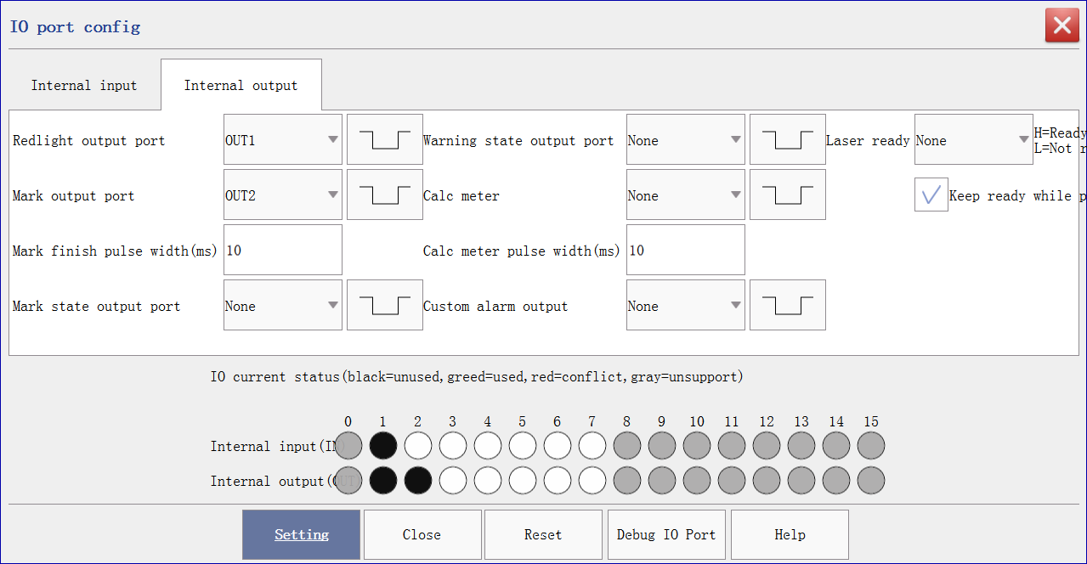
Image 5-8-2 output
IO polar instruction
:polar switch button,only low level signal valid.
:polar switch button,only high level signal valid.

IO state instruction
Example:
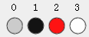
Port 0(color gray) means not support.
Port1(color black) means occupied.
Port2(color red) means conflict between multi setting.
Port4(color white) means free.

IO instruction
Input port
Trigger input:Laser will print automatically when the triggered signal is effective and the print mode is available under [triggered print] mode.
Outer control start:Like click start print button.
Outer control stop:Like click stop mark button.
Forbid mark lock:ignore all mark if valid.
Custom alarm 1:custom receive alarm input signal.Alarm info will be show before start marking.
Custom alarm 2:same with custom alarm 1.
Reset serialnumber:quick reset serialnumber objects in current edit document.

Output port
Infrared output port : Realize infrared preview.
Mark finish output port: this port will output an effective pulse when one mark is finished. The lasting time of the pulse is set by [mark finish pulse width]. A new marking will begin while the lasting time is effective and the setting of signal is invalid when marking is finished.
Mark state output port : the state of marking.
Warning state output port:output signal to specific port while occurs overspeed,missing mark or pipe line stopped.
Laser ready:output high signal level means machine running normal.
Calc meter:ouput signal for calculating linepipe moved length.The lasting time of the pulse is set by [calc meter pulse width].

Pin instruction
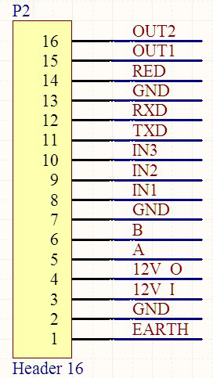
Image 5-9
Pin | Signal name | Instruction
1 | EARTH | EARTH
2 | GND | GROUND
3 | 12V_I | 12 to 24V power input
4 | 12V_O | 12V output
5 | A | Encoder A input
6 | B | Encoder B input
7 | GND | GROUND
8 | IN1 | 12V optocoupler configurable input 1
9 | IN2 | 12V optocoupler configurable input 2
10 | IN3 | 12V optocoupler configurable input 3
11 | TXD | COM 4,232 serialport output
12 | RXD | COM 4,232 serialport input
13 | GND | GROUND
14 | RED | Red light TTL output
15 | OUT1 | Configurable TTL output 1
16 | OUT2 | Configurable TTL output 2

5.4 Alarm config
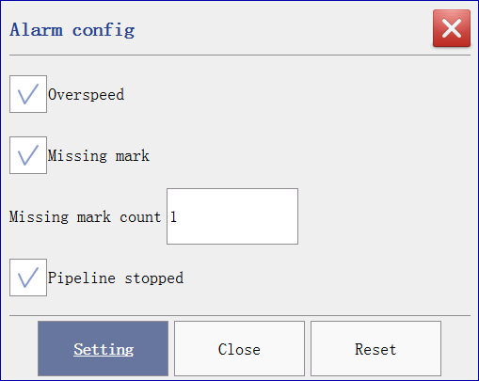
Image 5-10
Configure whether output alarm signal while occurs overspeed,missing mark or pipeline stopped.

5.5 System
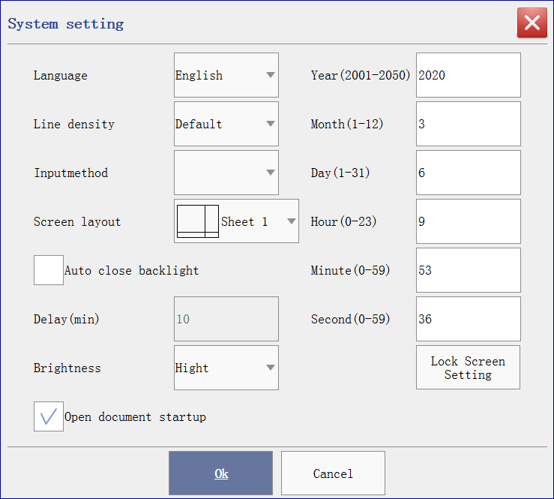
Image 5-11
Language:support English,Simplified Chinese,Traditional Chinese currently.
Line density:the object density in view.
Auto close backlight:close backlight after delay minutes timeout.
Input method:select different input language.
Screen layout:main screen layout selection.
Brightness:screen brightness setting.
Open document startup:whether open last marking document after machine startup.
Lock screen setting:lock screen display options.

5.6 Serialport
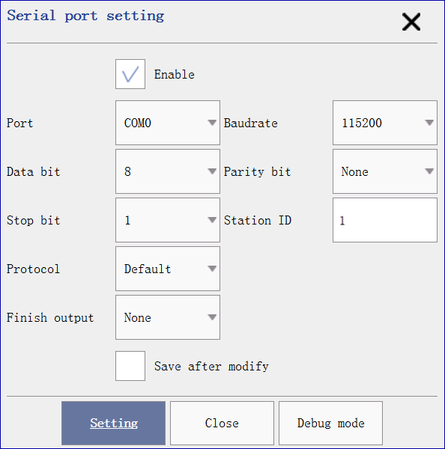
Image 5-12

5.6.1 Default protocol
Finish output:①None means no output after mark finished;②Static message means output fix message;③Print content means output print content;

5.6.2 Character stream protocol
Command char:Ascii or Unicode optional.Ascii will be sent with single byte,Unicode will be sent with double bytes.
Recv timeout:Keep the complete frame message from received bytes within the timeout.

5.6.3 Debug mode
For check and test whether the hardware has errors.

5.7 Network
Support wired and wifi network,IP address will be set automatically,or check static to modify it by hand.
Only support character stream protocol currently.
Port:laser system communicate IP port.
Command char:Ascii or Unicode optional.Ascii will be sent with single byte,Unicode will be sent with double bytes.
Recv timeout:Keep the complete frame message from receive bytes within the timeout.
Debug mode:for check and test whether the hardware has errors.

5.8 Authority
Only manager has permission to change the password of engineer/manager.

5.9 Param manager
Import laser params(laser calibrate,infrared calibrate,laser params,serialport params) to USB Disk or export from it to laser board.

5.10 History record setting
Output datetime:whether contains datetime in history record.
Record count limit:record count limit in signal database file.It will override old record or auto create new record file after record count overflow.
Preview:preview selected record file and do search with keyword.
Export:export current selected record file to USB disk.

5.11 Touch calibration
Click to do touch screen calibration.

5.12 About
Information about machine system version,device ID.

6 Entity list
Total created entity will be list in this view.It list the sequence of entity to mark.
Support move the selected object up/down,and the mark sequence will also be changed.See image 3-3.
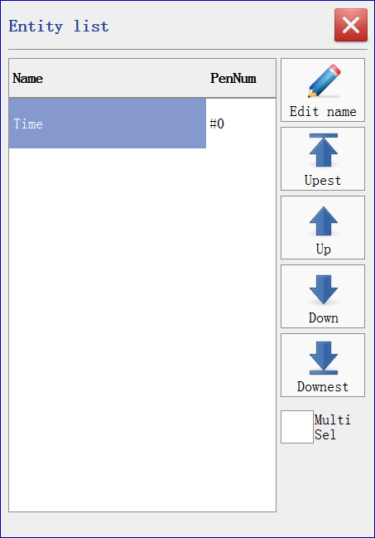
Image 6-1
Double click the entity can modify the name.

7 Res manager
Implements resource upgrade operations.
User can manager the resources,including documents,fonts,databases,vectors,images and calibrated parameters.Here introduce the document manager for example.
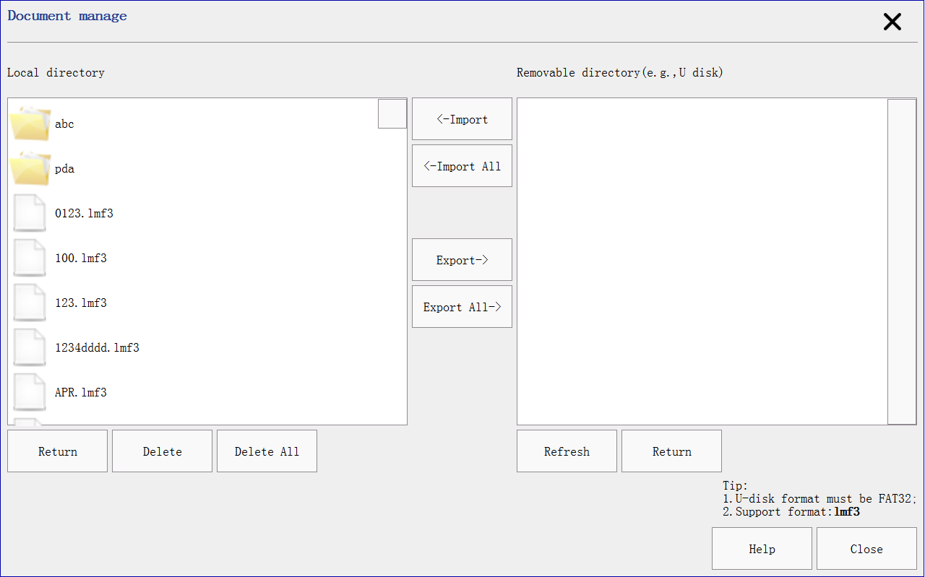
Image 7-1 document manager
Local files are listed in the left.Remote files(U Disk) are listed in the right.
Document:support import/export lmf3 files.
Font:support import/export TTF,SHX,DMF,LYF font files.
Database:support import/export csv(split with “,”) and txt files.
Vector:support import/export DXF,PLT format files.
Image:support import/export JPG,JPEG,PNG,BMP format files.
Laser calibration:support import/export laser calibration files.
Upgrade:upgrade to newer laser control system.
Warning:only support FAT32 format U Disk currently.

8 Toolbar

8.1 Time
Property can be devide two parts:general and specific property.
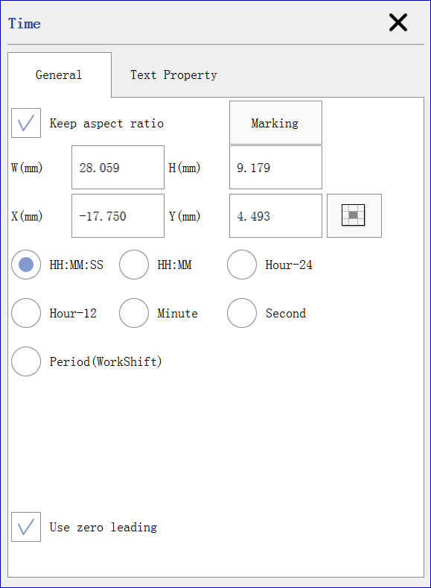
Image 8-1
General property contains width,height,position x,position y and marking control.
Width:actual width of current selected entity.
Height:actual height of current selected entity.
X/Y:actual position of current selected entity.
Close marking:ignore while marking.
Control port:communication control marking.See communication protocol for more.
Time property:see 8.10.2 Time.
Text property:8.3 Text.

8.2 Date
General property:see 8.1 Time.
Date property see 8.10.3 Date.
Text property:see 8.3 Text.

8.3 Text
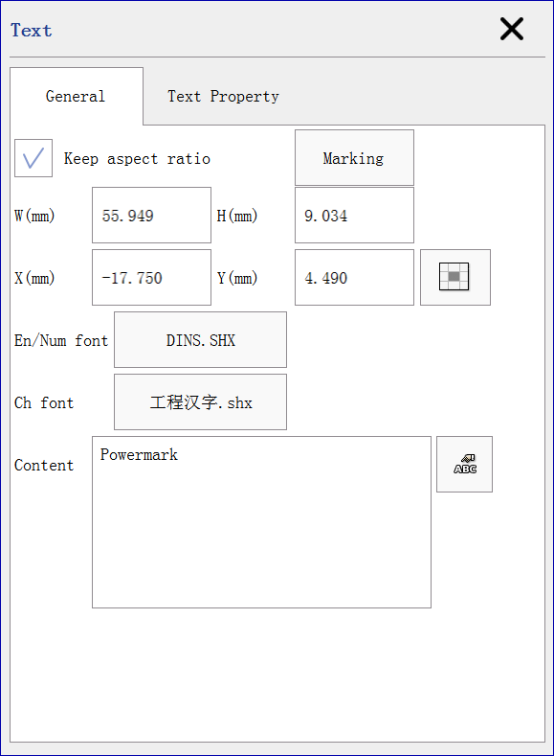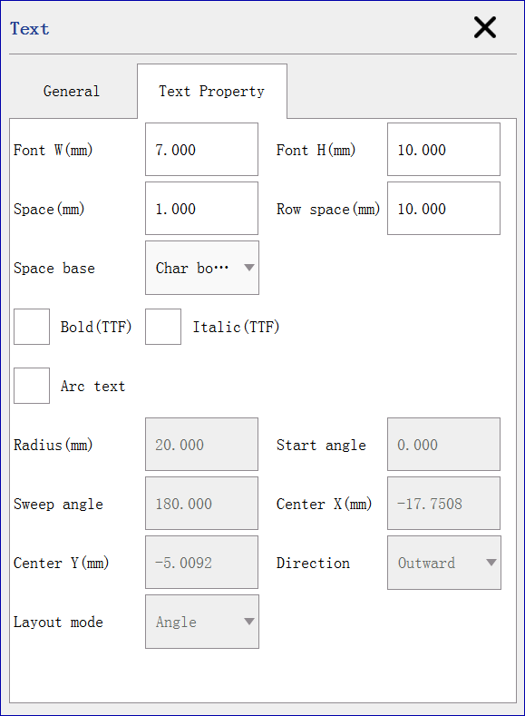
Image 8-2
General property:see 8.1 Time.
Text font support SHX,TTF,DMF(dot matrix font),LYF(custom font).
Support multiline text input in the content editor.
Space used again with Space base.Default char base is char bounding,that means the space is between right end of previous character and the left begin of next character.If char base is auto,space in the setting will be ignored,and its layout space read from the font.If char base is char center,then the position of characters will never changed,regardless the different characters.
Bold and italic will only valid in the TTF font.
Offer data without marking,normally used by the bridge text as the source content.

8.4 Serial number
General property:see 8.1 Time.
Serial number property:see 8.10.5 Serial number.
Text property:see 8.3 Text.

8.5 Barcode
Supported:Code128,Code39,Code93,Code11,CodaBar,C25Matrix,C25Inter,ExtendCode39,EAN128,EAN8,EAN13,UPCA,UPCE,ISBN,QRCode,PDF417,DataMatrix,DataMatrix_GS1.
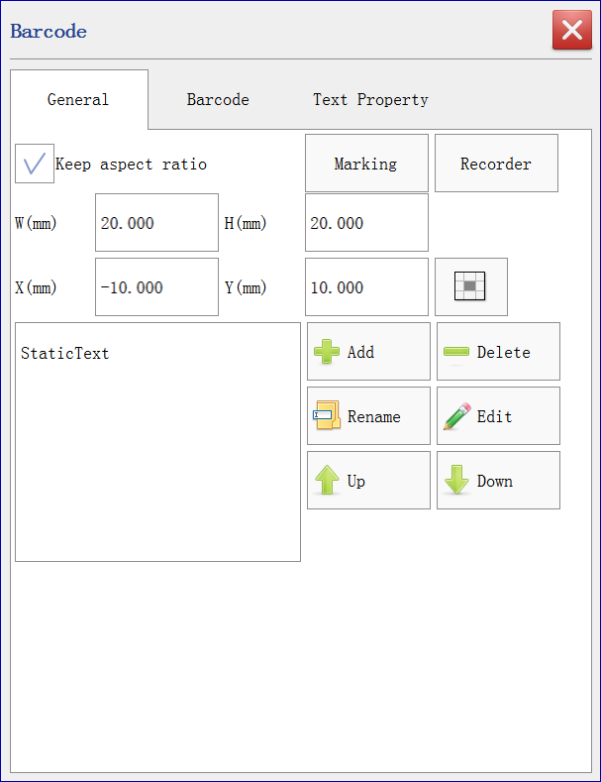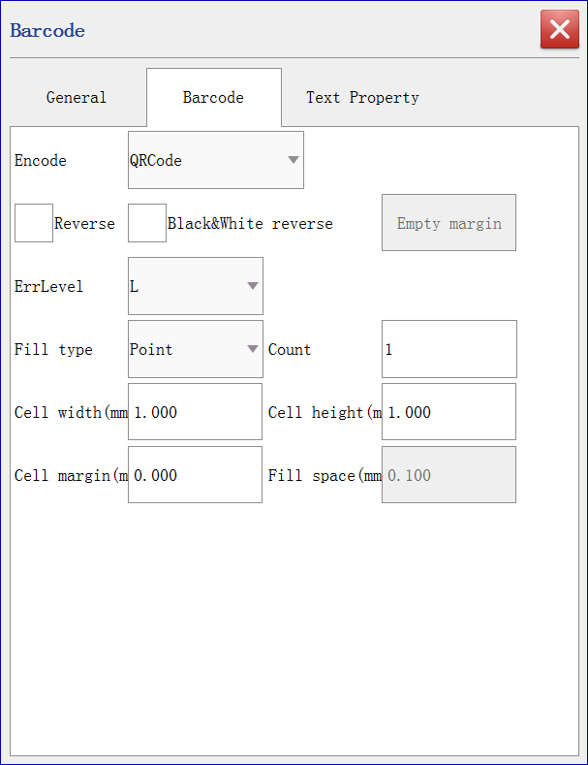
Image 8-3
General property:see 8.1 Time.
Text property:see 8.3 Text.
General barcode property:see image 8-4.
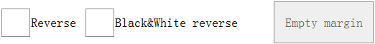
Image 8-4
One dimensional code property:see Image 8-5.
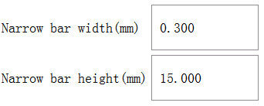
Image 8-5
Two dimensional code property:see Image 8-6.
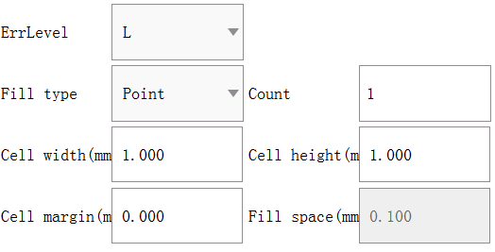
Image 8-6
Err level:L,M,Q,H four level.Higher level has larger data to be encode,and has higher correct level for error section in barcode.
Fill type:different fill shape in the barcode cell.
Cell width/height/margin:decide the size of barcode cell.
Center hole:remove cell in barcode center.You can place a photo in it.

8.6 Line
General property:see 8.1 Time.
Line property:contains X1,Y1 and X2,Y2 setting.
X1,Y1:the begin point of the line.
X2,Y2:the end point of the line.

8.7 Rectangle
General property:see 8.1 Time.
Round corner of percentage value to control the four corner.Convex can be look like 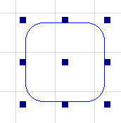,Concave can be look like 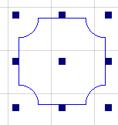.

8.8 Ellipse
General property:see 8.1 Time.
Enable split:split the ellipse/arc to multiple part count,each part is split to angle value.

8.9 Vector
Select vector file will insert vector entity to the document.Support DXF and PLT format files.

8.10 Composite text
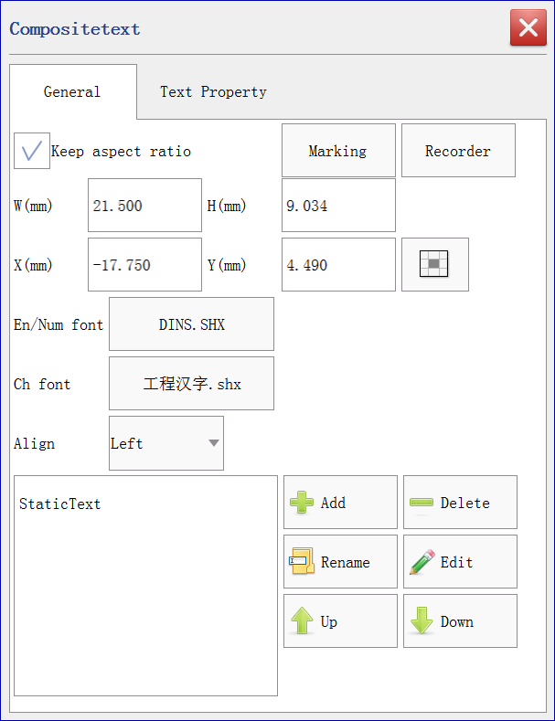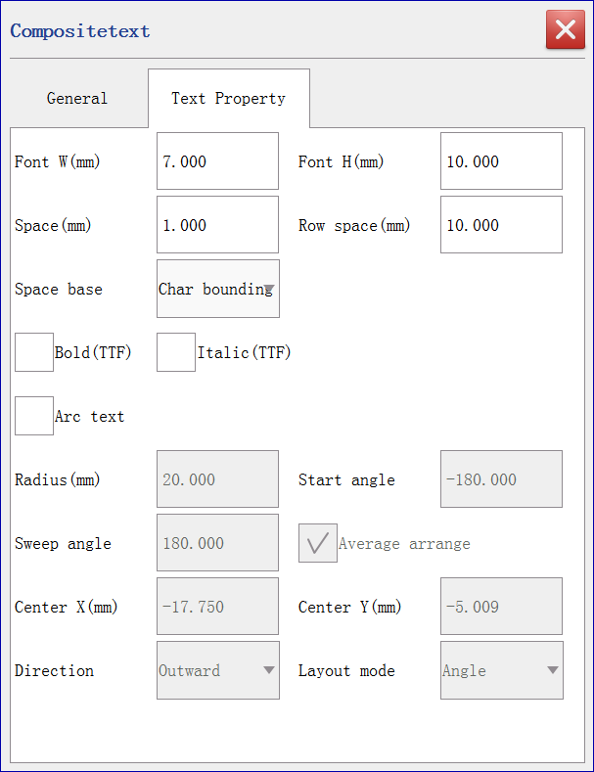
Image 8-7
General property:see 8.1 Time.
Text property:see 8.3 Text.

8.10.1 Static Text
Input static text.

8.10.2 Time
Current time text.Select period option,change the display text in relative time.

8.10.3 Date
Current date text.User can change the display text in the edit list in relative date.

8.10.4 Scanner
The same as keyboard input.Press enter will insert input text.

8.10.5 Serial number
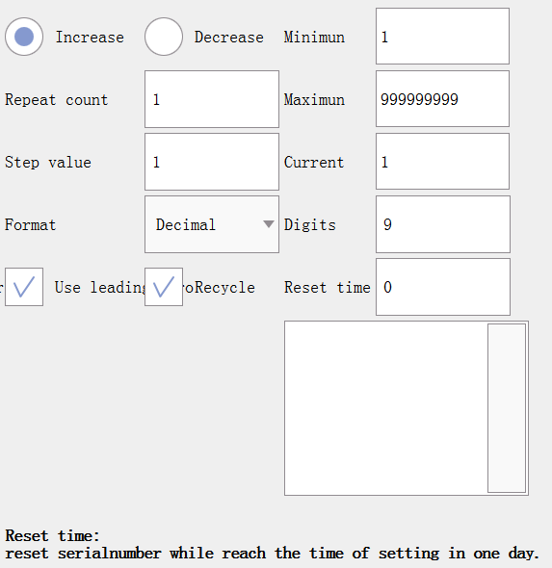
Image 8-8 Serial number property
Increase/Decrease:the change action.
Repeat count:the marking repeat count before changing to next value.
Step value:value increased/decrease while changing to next value.
Digits:digit count of the value.
Reset time:decide the reset count in different time.

8.10.6 Database
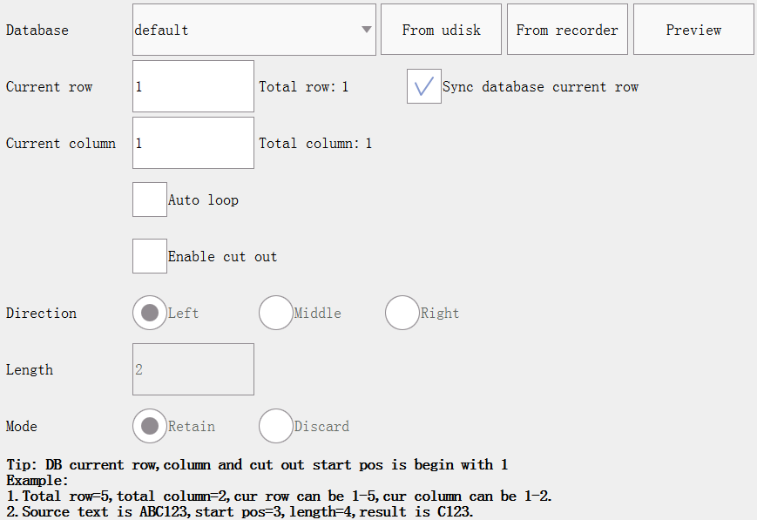
Image 8-9 Database property
TXT or CSV file can be import as database.
Enable cut out:cut a segment data from current row and column data.

8.10.7 New line
Add new line between combined text.

8.10.8 Bridge text
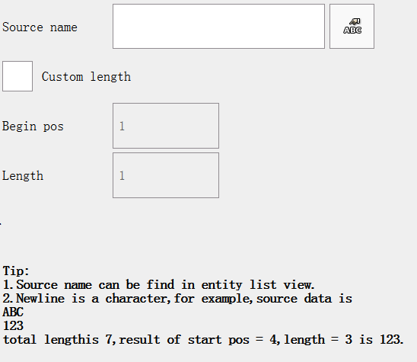
Image 8-10 Bridge text property
Associate with other entity.Bridge text content will be changed once the source entity changed.
Source name:can be fond in entity list view.

8.10.9 Random code
Dynamic code,support custom format.

8.11 Image
General property:see 8.1 Time.
Format:grayscale,dot,mono.Grayscale is from 0-255 gray level.Dot format simulate grayscale by white and black color.
Fixed DPI:fixed setting of DPI for high density marking.It will spend more time in marking with larger DPI.
Bidirection:marking sequence from L->R,R->L cycle.
Dot mode:mark dot with specific time.

8.12 Delayer
Do delay while marking.

8.13 Database
General property:see 8.1 Time.
Database property:see 8.10.6 Database.

8.14 VIN
General property:see 8.1 Time.
Other property:see 8.10.5 Serial number.

8.15 Delete
Remove selected objects from the current edit document.

8.16 Undo
Cancel previous operation.

8.17 Login
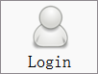engineer default password is 000000,manager default password is 111111.
User has no edit permission in unlogin state,and can open document to print only.
Engineer can edit document and modify mark params.Manager has the highest permission,it can modify laser params,correction params and other hardware parameters.

8.18 Zoom in/out
Scale larger the view based on center (0.0,0.0);
Scale smaller the view base on center(0.0,0.0).

8.19 No zoom
Reset the view size.

8.20 Watch
Show all objects in the document to scale the view.

9 Control panel
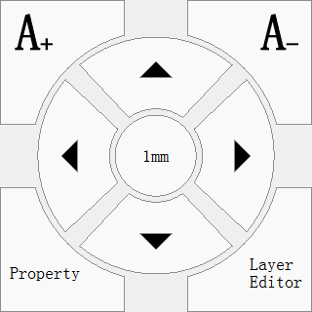
Image 9-1
1mm:the accuracy adjust for moving,click this to switch step value(0.1mm,1mm,5mm).
:larger the selected objects’ width and height with the accuracy step.
:smaller the selected objects’ width and height with the accuracy step.
:move direction control with the accuracy step.
Property:show the selected objects’ property.
Mark param editor:show the marking parameters,see 10 Mark parameters.

10 Mark parameters

10.1 PenNum
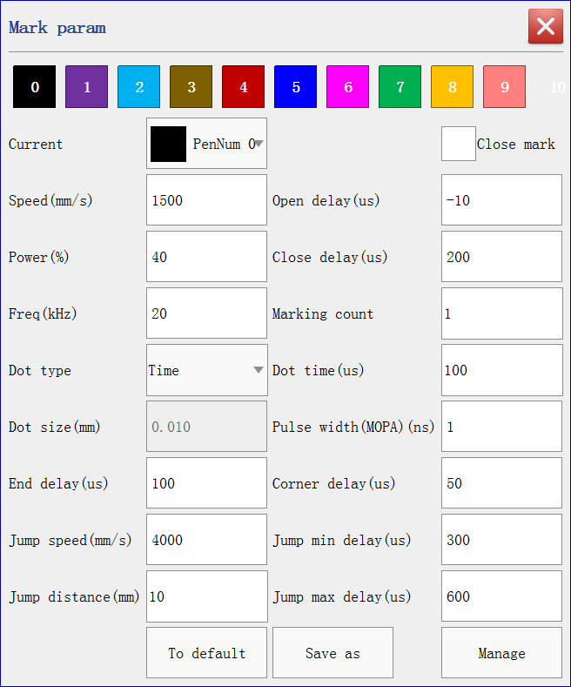
Image 10-1
Support 10(0-9) pen number selected in document.Different pen number mark can be set different mark parameters.
Current
The pen number of selected entities.

Marking count
The default numbers of times of repeated marking for all the objects in this pen number is 1. Marking , the parameter of this setting is invalid. the setting is not available when it is flight marking.

Open light latency
Definition: (unit : us), for the latency of laser, laser light delays to open for waiting galvanometer to finish the instruction (range from -2 to 2ms). Usage: galvanometer’s respond to the position sign lags behind the time that sign sent by the system during the process that the galvanometer jumps to next character or image from The current stopping point, so the laser light needs to delay opening to wait the galvanometer jumps to the corresponding position then sent out light. The setting is related to the response time of the laser. Generally, the value should be positive value. The value should be negative value when The response time of the laser setting out light is longer than that of the galvanometer. The value of CO2 laser and Fiber Laser are set as negative one.

Marking speed
Definition: (unit:mm/s),the swing velocity of marking when light sent from X and Y galvanometers in the interior of The scan head .(range from 1---20000mm/s)
Usage: note that speed is related to power and frequency. the faster the speed, the higher the frequency rate.
Parameter character: it affect efficiency directly. the bigger the value is, the shorter the marking time is. the smaller value is, the longer the marking time is.

Close light latency
Definition: (unit : us), for the latency of laser, laser light delays to close for waiting the response of the galvanometer to the final position instruction (range from -2 to 2ms).
Begin value: set as 100us. the value can be set smaller if the speed of selected galvanometer is fast enough or the marking speed is slow enough.
Usage: the response time of laser to “close light” instruction is shorter than that of the galvanometer to “end position ”instruction, so the laser light must delay to be closed for waiting the galvanometer to reach the response position. It related to marking speed. Set a appropriate “close light latency”to avoid “open phenomenon ”While close marking. If the value is set too big, “deep dot ” phenomenon will be caused at the end part.

Frequency
Definition: the numbers of pulses per unit time—that is the numbers of light spot set out per second.
Begin value: set as 20 KHz.
Usage: the bigger value is , the more and the closer the light spots in unit length. Appropriate margin of light spots is good to moderate effect.
Parameter character: the lower the frequency is, the higher the peak power is when other parameters is unchanged. And it has a better result of direct gasification to the material. The light energy effect displayed on high frequency should be closer to average power—that is more heating effect .

Jump speed
Definition: the swing velocity of X and Y galvanometers in the interior of the scan head while jumping (range from -2 to 2ms).
Usage: control the jump speed between strokes of marking characters or images( pattern). That is the moving speed of the galvanometer which turn to the first dot of the first character or the stroke, and the laser light is not sent in the middle.

Power
Definition:the relative power of laser(the actual power depends on the energy amount of the laser),(range from 1% to 100%).
Parameter character: the bigger value is, the more energy sent when other parameters is unchanged. so the color printed is darker and the mark is deeper.

Jump min delay
Min delay time for jumping.

Jump max delay
Max delay time for jumping.

Jump max distance
Max jump distance.
While actual jump distance < max Jump distance,actual jump delay = Min jump delay + (actual jump distance / Max jump distance) * (Max jump delay - Min jump delay).
While actual jump distance >= max jump distance,actual jump delay = Max jump delay.

Pulse width: the lasting time that laser power maintains in a certain value,only valid in MOPA.
Parameter character: under the same frequency, the bigger value is set, the lower peak power is.. this parameter is not available for CO2 laser.

Close light latency
Definition: the light is closed after the closing light latency finishes when the laser print a stroke. The laser needs some reaction-time to close light and the close light latency is the waiting time. It will go to next marking coordinate when the close latency is finished.
Parameter character: the laser has not closed the light and cause "bad-tail” if the latency value is too small. The marking time will be influenced if the latency value is too big.

Dot time
Definition: the time of light sent out while laser is printing dot—that is the time laser light stays at every dot printed.
Parameter character: the marking speed has no effect on the whole marking time while laser light print the lattice. The longer printing time is , the deeper mark is .

Corner latency
Definition: the latency time of the galvanometer signal at character corner.
Usage: if the setup of the latency time of the laser marking needs for character corner or arc line is not appropriate, “burned black” will appear at the character corner or arc line. The latency time is different because of the marking material and marking speed.

Enable spiral mark
Lines will be mark as spiral.Diameter determine the size of spiral.Spiral center distance determine the elastic.

10.2 Mark parameters manager
Save current pen number parameters to file,and can be found/modify in mark parameters manager.

11 Print mode
Support three mode:static,fly,linepipe.

11.1 Static
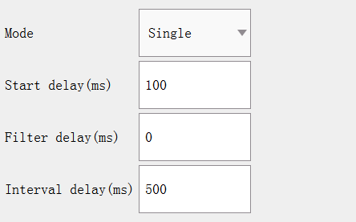
Image 11-1 Static mode
Mode:Single,Trigger and Continuous.
- Single:same with “Outer trigger output” IO control.Start one time marking.Start delay:delay time before ready for marking(not accuracy).Filter delay:ignore.Interval delay:ignore.
- Trigger:enter waiting mark state after print or “Outer trigger output” clicked.Begin marking once triggered by outer signal.Start delay:delay time before ready for marking(not accuracy).Filter delay:only response one time among the delay time.Interval delay:ignore.
- Continuous:continuously marking after print or “Outer trigger output” clicked.Start delay:delay time before ready for marking(not accuracy).Filter delay:ignore.Interval delay:delay time between previous and current marking.
- Repeat without break:repeat mark document without has time interval.

11.2 Fly
Mode:Single,Trigger,Continuous,Trigger continuous.
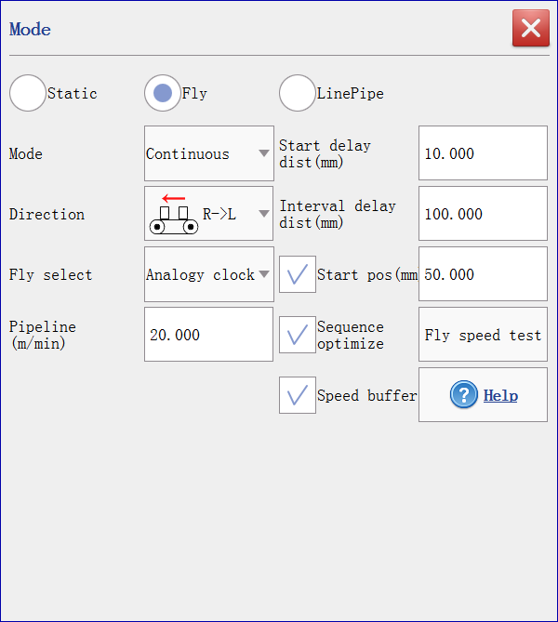
Image 11-2 Fly mode
Direction:direction of the pipeline.
Start delay dist:delay distance between ready and real marking.
Fly select:analog clock or encoder.
Compensate degree:correct degree for pipe line.
Pipeline:speed for pipe line.
Pulse width:one pulse width of encoder.Valid in encoder fly.
Filter delay dist:will ignore the trigger signal between the filter delay distance.
Interval delay dist:interval delay dist between previous and next marking.
Start pos:if checked,laser start marking while pipe line reach the position.If unchecked,laser start marking while pipe line reach the object’s position property,you can move the object to right for quickly marking if the direction is RightToLeft as example.
Sequence optimize:decide optimize the marking sequence to match the direction of pipe line.If unchecked,object will be mark with there place sequence in Entity list.
Fly speed assume:assume the max pipe line speed according to current setting params and marking content.
Speed buffer:decide to buffer marking content.

11.3 Linepipe
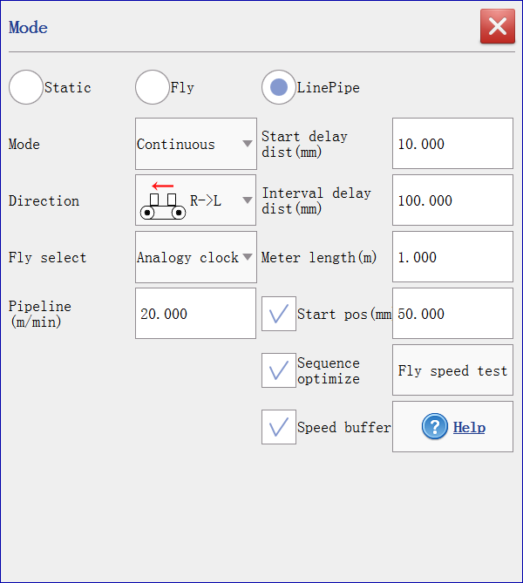
Image 11-3 Linepipe mode
Meter length:meter signal will output while reach this meter length.See IO Config.

12 Mark bar
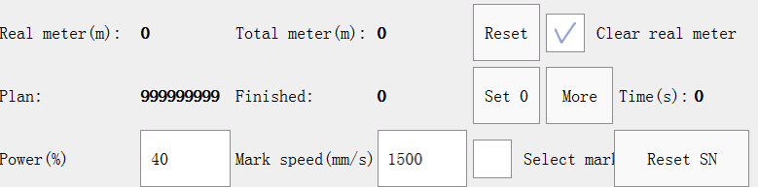
Image 12-1
Real meter:valid only in linepipe mode.Record the real time meter and reset zero while reach the setting Meter length.See IO config and linepipe.
Total meter:valid only in linepipe mode.Record the total meter length.
Clear real meter:reset zero to real meter.
Step:record count for one time marking.Finished = previous finished + step.
Plan:max mark count limit.
Finished:mark finished count.
Time:mark time of current document.
Power:current first pen number power in document.
Mark speed:current mark speed in document.
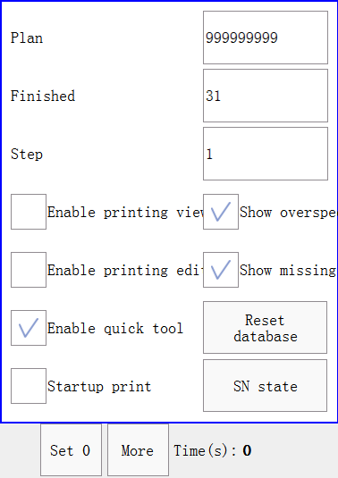
Image 12-2
Enable printing view:refresh document view while printing.Dynamic data can be real-time refresh in the document(such as serialnumber,database and time).
Enable printing edit:edit document while printing.
Enable quick tool:select to enable/disable quick tool display in edit viewport.
Startup print:auto start print after machine start finished.
SN state:review/reset serialnumber in current edit document.

13 Status bar
Version:
Login user:
Current document:
Line pipe state:
Document state:
Current line pipe speed:
Network state:(connected/disconnected)

